2018 SHOW CLINIC SCHEDULE

Lee Smith
June 9 & 10
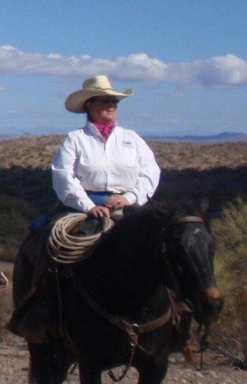
Lee is a gifted and eloquent teacher who has extraordinary insight into horses and people. She shares what she sees as if speaking for the horse and thus provides her students with the opportunity to observe the exchange of communication between horse and human. Teaching people to learn from the horse.
Lee leads people on a pathway of discovery to the essential elements of horsemanship. She helps them to unlock their potential to understand the mind, body and spirit of the horse using what naturally happens, and then shows them how to appreciate and build upon the incredible moments of harmony that are possible. Lee believes that through life's experiences (horse related or not), the answers lie within us.
For information on clinic registration contact Wendy Woldt at 920-493-1705

CRAIG CAMERON
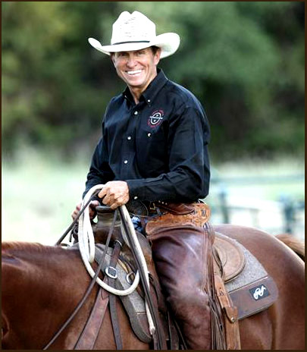
June 15, 16 & 17TH
It’s about HORSEMANSHIP. Develop that willing partner with a slow hand and loose rein, “taking the fear out of the horse”.

For reservations and more info contact Kelley Lindsley at farsideranch@wizunwired.net or call 920-660-8920.
Lunch available every day in the Cowboy Café @ Idlewild Farms, hotel accommodations & restaurants nearby in Sturgeon Bay.
Auditors welcome! $30/day

Drillteam Competition
August 4th
Contact Faye Bley @ 920-495-9207
Door County Fairgrounds

Barn Dance
August 25th
Idlewild Farm

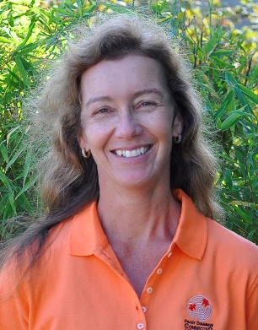
Deborah Davies Clinic
October 20 & 21, 2018

FOR MORE INFORMATION OR TO REGISTER PLEASE CONTACT
Janet Gerl (920) 493 – 0909
$200 per rider spot for the two days of instruction

Saturday, October 20th:
- 9:00 - 12:30 = Short lecture and ground work demo for all taking lessons and auditors. This is to increase educational concepts and ground work tools, applying to lessons later.
- 12:30 – 4:00 = Lessons begin. Lessons may be a mix of groundwork and riding - more individualized per rider. Lessons can be continued on Sunday as needed.
Sunday, October 21st:
9:00 – 12:30 = Groundwork and riding
12:30 – 4:00 = Riding

Costs: *$200 - Lecture, groundwork and clinic, *$125 – Static Groundwork for new horse, *$100 – Static groundwork for horses Deb has previously worked on. *Audit fee's - $30 per day Static Groundwork = body therapy

Stalls available on request - $10 / night - you clean when done.

Brad Hall
Monthly Lessons
Contact Wendy Woldt @ 920-493-1705

