On January 31-February 1 American Gymnastics will hold its 21st American Invitational at the XL Center in Hartford, CT. This is currently the only coed Invitational in the New England region. This meet provides the opportunity for teams throughout the region to come together and demonstrate their skills in a competition that is sanctioned by the USA Gymnastics federation. These larger competitions give children a chance to meet other gymnasts and share their knowledge and talents of the sport before a sizeable crowd.

As many as 650 gymnasts are scheduled to participate and as many as 2,500 attendees will view the list of individual and corporate sponsors supporting our Invitational. We hope we can add your name to the 2014 list of sponsors. It is through various donations and fundraising efforts that we are able to offset the expenses associated with such a large event.

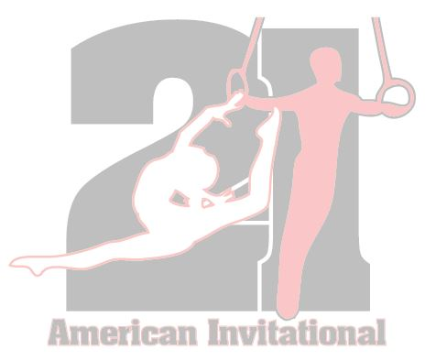
We appreciate your taking a moment to consider our request and hope to count you as one of our many supporters. For additional information, or if you have any questions, please feel free to contact our gym at 860.621.5001.

Sincere thanks from the American Gymnastics Parent Organization, Inc.

Thank you for your donation to the 21st Annual American Invitational!

Business:

Contact Name: Contact Phone:

Contact Email:

I/Our Business will be donating the following: $________________ OR specific product below:

I am authorized to commit the above-mentioned business to sponsor/donate the above product or dollar amount to the American Invitational for 2014, in exchange for the agreed upon publicity.
My signature initiates this agreement.

Print Name Authorized Signature Date

