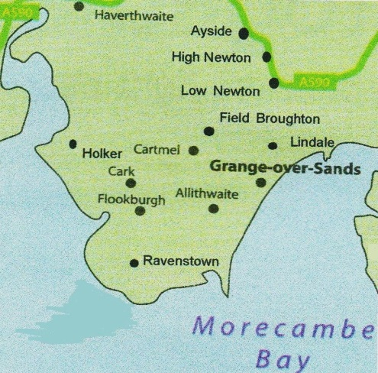
Cartmel Peninsula Local History Society
2015 programme of lectures

www.cartmel-peninsula-lhs.org.uk

7.30pm at Cartmel Village Hall normally on 1st Thursday of the month. Free parking on site.

Summer trips
25 June 2015 – Trip to Sizergh Castle – gardens and architecture tour.
Meet at 1:30pm for a self-guided tour of the Castle. 3:30pm: Guided tour of the castle exterior and grounds by Russ & Mike. Cost: £8.90, or free for NT members. Contact Stuart Harling to book (s.w.harling@gmail.com) or Tel 36296.
If oversubscribed then possibly another tour date can be arranged for September.

30 July 2015 – Trip to Wordsworth Cottage, Grasmere
Meet at 2:00pm. Archives on Dorothy will be available, and there is the Wordsworth, War and Waterloo exhibition and a tour of Dove Cottage all included. Cost £5.60. Contact Stuart Harling to book (s.w.harling@gmail.com) or Tel 36296.

Autumn lectures
At Cartmel Priory an additional lecture organised by Cartmel Peninsula Local History Society
Monday 7 September 2015 – Dr Alan Crosby - King John was a Bad Man: Understanding Magna Carta on its 800th Anniversary.
Following his lecture last year on the Monasteries of North West England, Alan returns to be part of the Cartmel Priory Festival. We have organised this lecture in conjunction with Cartmel Priory and although there will be an entry charge of £2.50, our CPLHS Members can attend the lecture at the Priory without charge.

Cartmel Village Hall
Thursday 3 September 2015 – Dr Rob David - The Yellow Earl's (Fifth Earl of Lonsdale) big adventure: the Arctic Journey of 1888-1889.
A retired lecturer and independent researcher we welcome back Rob whose lecture gives us an insight into the life of an occupant of Lowther Castle.

Cartmel Village Hall
Thursday 1 October 2015 - Professor Angus Winchester – The Victoria County history Project; what has been achieved and what the plans are for the future.
A popular speaker from the History Department of Lancaster University who has been running the project and is the County Editor

Cartmel Village Hall
Thursday 5 November 2015 - AGM

If you have any questions please contact Pat Rowland on 015395 32234 or email patrowland_uk@yahoo.co.uk (v6 090615)

