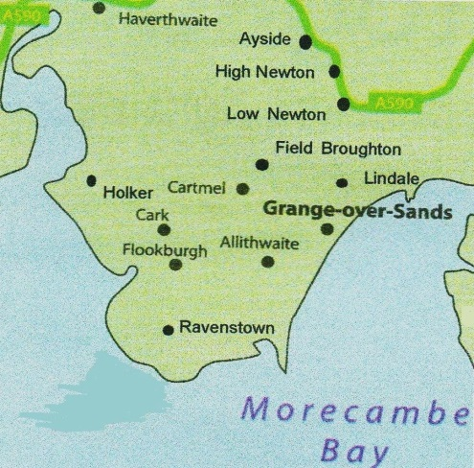
Cartmel Peninsula Local History Society
2016 programme of lectures
Celebrating 20 years of lectures
Established 1995, lectures began in 1996.

www.cartmel-peninsula-lhs.org.uk

7.30pm at Cartmel Village Hall normally on 1st Thursday of the month. Free parking on site.

Cartmel Village Hall

Thursday 4 February 2016 – Ken Howarth – Rocks, Lakes and Early History
Lecture originally given by Murray Mitchell in 1996, Ken will give us an insight into current thinking on these issues in respect of the Cartmel Peninsula.

Thursday 3 March 2016 – Ian Boyle – Archaeology in the Duddon Valley – Ian will tell us about the Ring Cairns to Reservoirs (R2R) project that Duddon Valley Local History Group were involved in.

Thursday 7 April 2016 – Les Gilpin – The Development of the Furness Railway.
Chairman of the Cumbria Railways Association and author of The Ulverstone and Lancaster Railway, Les was born and raised in Cark and has been fascinated by the local railway all of his life.

Thursday 5 May 2016 - Dr Mike Winstanley - Roughs and Respectables: the pleasures and problems of leisure. A retired senior lecture from Lancaster University Mike’s talk is about how Victorians entertained themselves, were entertained and how authorities responded.

Thursday 1 Sept 2016 – Emma Wright – A taste of Townend : recreating recipes from 1699. The manager of the National Trust property at Townend, Troutbeck will tell us about the Browne family and their life. A similar talk was in the 1996 programme

Thursday 6 October 2016 - Andy Lowe – Discovering a landscape of Industry (Lakeland Old Crafts and Industries). One of our most popular speakers, Andy spoke on this topic in October 1996.

Thursday 3 November 2016 - AGM

If you have any questions please contact Pat Rowland on 015395 32234 or email patrowland_uk@yahoo.co.uk (v1 090615)

