-
Fenix CL09 Camping Lantern

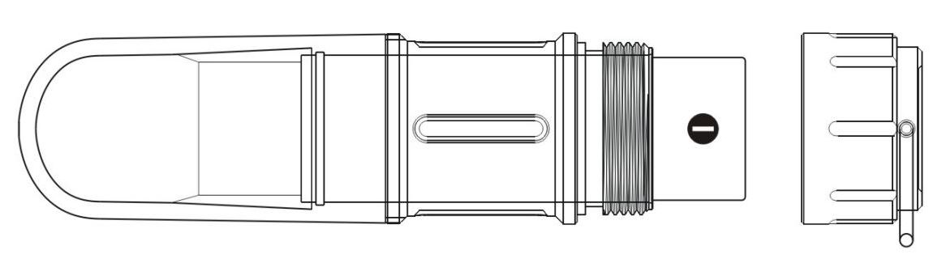
- Tighten/Turn on
Loosen/Turn off
- Battery

Technical Parameters
 |  | Low | Med | High | Turbo | Red | Red Flash | Green
Output |  | 1  Lumen | 30  Lumens | 80  Lumens | 200  Lumens | 5  Lumens | 5  Lumens | 5  Lumens
Runtime | ARB-L16-700U | 90h | 19h  20min | 5h  40min | 2h  40min | 30h | / | 48h
 | CR123A | 150h | 36h | 19h | 6h | 48h | / | 76h
Beam Diameter |  | ±10m
Impact resistance |  | 1m
Waterproof |  | IP68, underwater 2m
Notice: The abovementioned parameters (lab-tested by Fenix using the included ARB-L16-700U and one CR123A battery) may vary between lanterns, batteries and environments.

- Three lighting sources of neutral white, red and green
- Powered by one ARB-L16-700U, 16340 or CR123A battery
- 78.5mm Length x 22mm Diameter
- 31.5 grams (excluding battery and other accessories)
- 360° illumination
- The lantern tail features a magnet and a hanging loop
- IP68 rating, underwater 2m for 30 minutes
- Reverse polarity protection, to protect from improper battery insertion
- Made of durable aircraft-grade aluminum and optical grade PC materials
- Premium type III hard-anodized anti-abrasive finish

Operating Instruction
ON/OFF
Tighten the lantern tail to turn on the lantern. Loosen to turn off the lantern.
Output Selection
To change output level while the lantern is switched on, turn it off and back on again within one second. Lantern will cycle through Low→Med→High→Turbo→Red→Red Flash→Green.
Note: the lantern is not equipped with a memory function. If more than one second elapses after being switched off, it will default to Low mode when switched on again.

Battery Specifications
Type | Dimensions | Nominal Voltage | Usability
ARB-L16-700U | 16340 | 3.6V/3.7V | Recommended | √√
ARB-L16-700 | 16340 | 3.6V/3.7V | Recommended | √√
CR123A | CR123A | 3V | Recommended | √√
Rechargeable Battery  (Li-ion) | 16340 | 3.6V/3.7V | Cautious* | ！
*16340Li-ion batteries are powerful cells designed for commercial applications and must be treated with caution and handled with care. Quality batteries with circuit protection will reduce the potential for combustion or explosion but cell damage or short circuiting are potential risks the user assumes.

Battery Replacement
Unscrew the tail cap to insert the battery with the anode side (+) towards the light head, then screw the tail cap back on.
Charging of Fenix ARB-L16-700U
- Unscrew the lamp cap , take out the battery, plunge the charging cable into the battery built-in micro USB port. Or charge the battery in a charger.
- When charging via micro USB port, the charging indicator turns red, and blue when fully charged.
- When fully charged, disconnect the charging cable or remove the battery from the charger, and insert the battery with the anode side (+) towards the lamp head, then screw the tail cap back on.
- Recharge a stored battery every four months to maintain optimum performance of the battery.

Parts Included
- 1*CL09 camping lantern
- 1*Spare O-ring for water seal
- 1*Key ring
- 1*User manual
- 1*Warranty card
- 1*Fenix ARB-L16-700U

Usage and Maintenance
- Disassembling the sealed head can cause damage to the light and will void the warranty.
- Fenix recommends using excellent quality battery.
- If the light will not be used for an extended period, remove the battery, or the light could be damaged by electrolyte leakage or battery explosion.
- Long-term use can result in O-ring wear. To maintain a proper water seal, replace the ring with an approved spare．
- Periodic cleaning of the battery contacts improves the lamp's performance as dirty contacts may cause the lamp to flicker, shine intermittently or even fail to illuminate for the following reasons:
A: The battery need replacing.
Solution: Replace battery (Ensure battery are inserted according to the manufacturer’s specifications).
B: The threads, PCB board contact or other contacts are dirty.
Solution: Clean the contact points with a cotton swab soaked in rubbing alcohol.

If the above methods don't work, please contact your authorized distributor.

Warning
This flashlight is a high-intensity lighting device capable of causing eye damage to the user or others. Avoid shining the flashlight directly into anyone’s eyes.

