Fenix LD42 Flashlight

Specifications
ANSI/PLATO FL1 | Turbo | High | Med | Low | Eco | OFF
Output | 1000 lumens | 350 lumens | 150 lumens | 50 lumens | 5 lumens | /
Runtime | 1 hours 10minutes* | 2 hours 38 minutes | 13 hours 10 minutes | 36 hours 40 minutes | 130 hours 20 minutes | /
Distance | 350 meters | 190 meters | 125 meters | 72 meters | 23 meters | /
Intensity | 30625 candela | 9025 candela | 3906 candela | 1296 candela | 132 candela | /
Impact Resistance | 1 meter
Waterproof | IP68, 2meters underwater
Note: The above specifications are the test results given by Fenix through its laboratory testing using 4 Pairdeer batteries under the temperature of 21±3°C and humidity of 50% - 80%. The true performance of this product may vary according to different working environments and the actual batteries used.
*The Turbo output is measured in total of runtime including output at reduced levels due to temperature or protection mechanism in the design.

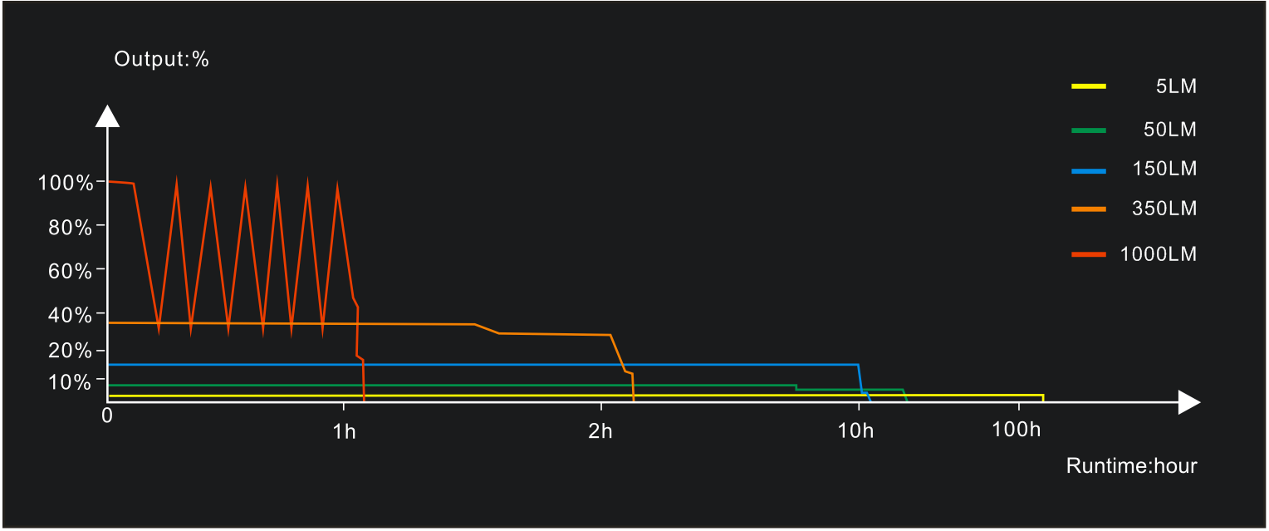

- 1000 lumens max output and 350 meters beam distance
- Patented technique of rotary mode switching - fast operation and accurate selection
- Powered by 4 AA (Ni-MH/alkaline) batteries
- 6.28'' x 1.34'' x 1.28'' (159.5 x 34 x 32.5 mm)
- 3.53 oz / 100 grams (excluding batteries)
- Stainless steel body clip
- Flat body design for comfortable holding
- Digitally regulated circuit for maintaining a stable output
- Reverse polarity protection, to protect from improper battery insertion
- Body with anti-roll and anti-slip design
- Light head is made of durable high-strength and oxidation-resistance aluminum; light body is made of quality plastic
- Premium type HAIII hard-anodized anti-abrasive finish
- Toughened ultra-clear glass lens with an anti-reflective coating

Operating Instruction
On/off
Rotate the mechanical switch to the right side to turn on the light; rotate the switch back left to the OFF mode to turn off the light.

Output Selection
Rotate the mechanical rotary switch to cycle through OFF⇄Eco⇄Low⇄Med⇄High⇄Turbo.

Battery Specification
Type | Dimensions | Nominal Voltage | Usability
Ni-MH Battery | AA | 1.2V | Recommended | √
Alkaline Battery | AA | 1.5V | Usable | √
Non-rechargeable Battery (Lithium) | AA | 1.5V | Usable | √
Rechargeable Battery (Li-ion) | 14500 | 3.7V | Banned | ×
Warning: 1. Do not use the banned battery in case of overvoltage burnout in circuit component.
2. Use quality batteries. Do not mix batteries of different brands, sizes, capacities or types. Doing so may cause damage to the lantern or the batteries being used.
3. If the light will not be used for an extended period, remove the batteries from the light in case of damage by electrolyte leakage.

Battery Replacement
Unscrew the light head to insert the batteries with correct polarity in accordance with the graphics on the top surface of the battery compartment, then screw the light head back on.

Overheat Protection
The light will accumulate a lot of heat when used on Turbo for extended periods. When the light reaches a temperature of 60°C or above, the light will automatically step down to 300 lumens to reduce the temperature. When the temperature drops below 60°C, it will then automatically return to Turbo mode.

Usage and Maintenance
- Disassembling the sealed head can cause damage to the light and will void the warranty.
- Fenix recommends using quality batteries with proper built-in protections.
- If the light will not be used for an extended period, remove the batteries, or the light could be damaged by electrolyte leakage.
- Unscrew the tail cap half a turn or take out the batteries to prevent accidental activation during storage or transportation.
- Long-term use can result in O-ring wear. To maintain a proper water seal, replace the ring with an approved spare (included) when damaged.
- Periodic cleaning of the battery contacts improves the light's performance as dirty contacts may cause the light to flicker, shine intermittently or even fail to illuminate for the following reasons:

A: The batteries need replacing.
Solution: Replace batteries (Ensure batteries are inserted according to the manufacturer’s specifications).
B: The threads, PCB board contact or other contacts are dirty.
Solution: Clean the contact points with a cotton swab soaked in rubbing alcohol.

If the above methods don't work, please contact your authorized distributor.

Included
LD42 flashlight, 4 AA batteries (alkaline), Body clip, Lanyard, Holster, Spare O-ring, User manual, Warranty card

Warning
- This flashlight is a high-intensity lighting device capable of causing eye damage to the user or others. Avoid shining the flashlight directly into anyone’s eyes.
- This flashlight will accumulate a lot of heat when used for extended periods, resulting in high temperature of the flashlight shell. Pay attention to safe use to avoid scalding.

