I Was A Few Bad Apples: The Ballad of a Culprit/Victim – Retired Chief U.S. Marshal
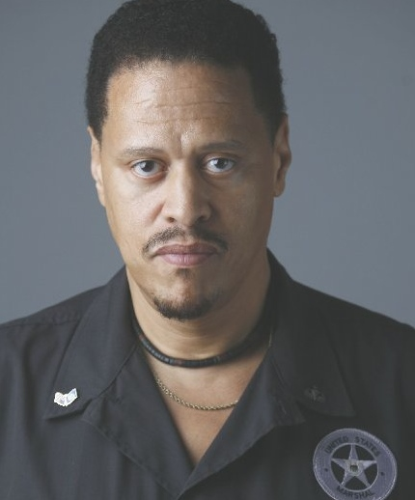
DR. MATTHEW F. FOGG
Injustice anywhere grieves me everywhere. My passion is justice ... as a decorated career Federal Law Enforcement Officer. I was a bad apple by default. Like most cops and colleagues, we the majority did not directly participate in human and civil rights abuses of citizens, but we were all very complicit with our silence. We acquiesced. We sell out, we stand still in shock, hands tied, and in silence while the bad apples construct havoc.

We witness abhorrent actions by racist co-workers who change the rules of engagement and practice extraordinary biases in enforcement operations and internal affairs. These lawless individuals destroy our ethical intentions to be officers of peace and protection from the inside out. These bullies are the bowels of policing and they remain unhindered today.

“I can’t breathe”. “My stomach hurts”. “I’m in pain all over”. “Don’t kill me”. “Mama”. “Please help”. These were virtual pleas from George Floyd in the hands of four Minneapolis Police Officers heard around the world and echoing similar pleas from Eric Gardner 6 years earlier ruled a homicide by New York Police Officers. This bias and abusive policing is now a public crisis with and without cameras. Bad Apple’s behavior is the unfortunate dehumanizing culture of our work. The European Union and the National Organization of Blacks In Government adopted Resolutions condemning structure racism in America and its police departments. Yes, the same attitude that kills, arrest and incarcerates black suspects with far less justification than for whites, exists inside most if not all of the nation’s federal, state and municipal law enforcement rank and file, top to bottom. The FBI microscopic hair analysis errors disproportionately convicted thousands of black suspects. U.S. Customs and DEA racially profiled thousands of black travelers and drug violators respectively, validating systemic racism. Everyone one of these FED agencies faced internal class action complaints alleging structural racism affecting black employees. But they always say, “it’s just a few bad apples”.

At 18 years young I was charged with Robbery and arrested at my home. I was detained three traumatic days in lockup by a white D.C. police detective who simply claimed later, he mistakenly charged me and another young black male witness on official reports, assuming we were the suspects. After college my record was discovered and expunged.

Last year, I was placed against a wall with hands and feet spread, searched, detained and harassed for over 45 minutes inside my new home by five white Montclair, New Jersey police officer’s claiming they received a call that I was a burglary suspect.

They completely dismissed my retired Chief U.S. Marshals credentials and driver’s license as instant verification of my identity and credibility while they proceeded to search my entire house and car. I made it clear, they would have treated me differently had I been white.

My name is Dr. Matthew Fogg. I am a cable news network guest law enforcement analyst and a retired Chief in the United States Marshals Service (USMS) supervised by the U.S. Department of Justice (DOJ). Which stating again, made me a bad apple by default.

My first call to duty was in 1978. Fresh in the field after months at the esteemed Federal Law Enforcement Training Center (FLETC) in Glynco, Georgia, my supervisor hastily stated, “forget that stuff they taught you in the Academy - this is how we do things here.”

‘Welcome aboard the Enterprise - a culture of indifference’ is what I heard. One of my first encounters with this was when I saw a black prisoner being abused by a white U.S. Marshal colleague and I stopped it! Consequently, my abusive colleague reported me to a supervisor for preventing him from restraining the prisoner instead of truthfully stating, I prevented him in his rage from unnecessary torture of a black life that didn’t matter to him.

I came to the conclusion that black lives really didn’t matter soon after being employed in the USMS. Yes, we the people – the police, bounty hunters, prosecutors, judges, wardens, court appointed lawyers, legislators, and society, have aided and abetted our national criminal justice’s atrocities where the death and demise of black and brown citizens is wholesale and standard operating procedure.

Police and Union officials keep saying, “it’s just a few bad apples” and “they are just doing their jobs.” These dismissive attitudes are a far cry from justice. With the horrendous death of George Floyd and a continuous accumulation of unjustifiable police homicides and abuse scenarios nationwide, supported by undeniable witness videos and worldwide protests, we are positioned to bring down a giant bully that is amassing unending human rights violations. That is, if we decide to address systemic and bias targeting of marginalized and often innocent men, women and young people in our black communities by the bad apples we have hired.

As an employee, to challenge internal bigotry within the DOJ, our nation’s premiere Federal law enforcement agency took a lion’s share of effort. Still, I did it.

I named internal bias procedures that affected me and my colleagues and ultimately our integrity that infects the process in interacting with the citizens we swore to protect and serve. I broke the code of silence and was admonished vehemently by my colleagues and friends to not do it, saying I cannot police America’s ongoing ageless crime of racial discrimination.

They said, “Fogg, (aka Batman) you are rare. A black Marshal with a degree and a distinguished enforcement record, you are most likely to succeed. We love you man, but management will come after you and then we can’t be associated with you. So, just turn your head from acts of injustice and wait until you get to the top - then fix it.” Thinking through their evils, I rotted on the good apple tree as did other black U.S. Marshals and law officers in America. We bowed down like characterizations in the historic Slave novel, ‘Uncle Tom’s Cabin’, quietly falling into the bad apples’ basket just going along to get along.

7 years after my entrance-on-duty date, I stopped turning my head and I rose from the
ashes like the phoenix. Rather, I turned my discontent and resolve instead against those who commissioned me, holding onto the belief that God would protect me much like in the biblical story of, Paul on the road to Damascus. And so, the good apples, in their fear of retribution drifted away from me watching the bad apples turn all guns to bear upon me and colleagues who chose to take a stand for equality. We who dared to blow-the-whistle on the infectious racism from within the command and control environment were viciously chastised and/or fired at the behest of the highest levels of the U.S. Marshals Service.

In 1997 black U.S. Marshals, FBI, U.S. Customs & Boarder Patrol, DEA and other Federal Agents testified before Maxine Waters, Chair and the Congressional Black Caucus (CBC) blowing-the-Whistle on the bad apples inside the rank and file.

We who testified were later terrorized with retribution. One black Inspector Deputy Marshal William Bill Scott and EEO Complainant died in a suspicious car accident soon after he retired. His white Jewish partner and supporter Stephen Zanowic, Jr. deputy U.S. Marshal was given a black rubber rat by a New York supervisor and forced off the job while dodging threats on his life.
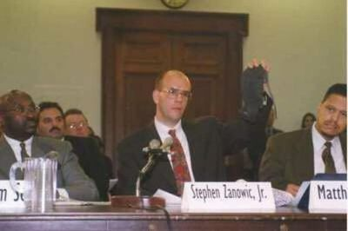
Deputy U.S. Marshal Zanowic Jr. testifies before the U.S. Congressional Black Caucus (CBC) In D.C. holding up a black rubber rat given to him by a White supervision after Zanowic reported racism against his black partner (LF in photo) who later died from injuries in a suspicious car accident. Supervisory Inspector Matthew Fogg testified (RT in photo)

A 1998 Federal Jury Verdict sustained that I had been subjected to a racially hostile environment since 1985 (original EEO Complaint) that affected all black deputy U.S. Marshals, nationwide and beyond 1991. The Court’s ‘Memorandum And Order’ stated, “Nevertheless the jury obviously inferred from the evidence of the endemic atmosphere of racial disharmony and mistrust within the USMS that all explanations were suspect, and that occult racism was more likely the reason than any other for Fogg’s misadventures with the Marshal’s Service Hierarchy” [Civil Action No. 94-2814 (TPJ)]

Today, 35 years later I am the lead plaintiff in a class action lawsuit dating back to 1994 claiming racial inequities in the same USMS Hierarchy. [Matthew Fogg, et al., v. William Barr, Attorney General, US/DOJ EEOC NO. 579-2016-0050X]

My lifelong employment discrimination litigation has named 19 appointed and acting U.S. Attorney Generals from Edwin Meese to William Barr (2nd Term) under 6 U.S. Presidents to present. This epic journey alone epitomizes a structural and systemic racial hostile environment in the U.S. Department of Justice that’s reinforced with the legal maxim justice delayed is justice denied.
Fogg authored a Blacks In Government Resolution that supported creation of the federal Whistleblowers Protection Act (WPA) of 1989 with 2018 enhancements that protects Federal employees and applicants who lawfully disclose information they reasonably believe evidences waste, fraud and abuse. Federal employees may not take or fail to take or threaten to take; any personnel action against an employee because of the employee or applicant’s protected “whistleblowing”.

Today the U.S. Marshals Service continues to harass whistleblowers in the midst of outstanding litigation. Until bad apples in federal, state and municipal law enforcement are held fully accountable for allegations of civil and human rights violations on black and brown citizens, the good apples will always fall prey as culprits and/or victims to the worst among us. Until police departments in every region are required by federal mandate to prove they are practicing equal justice in enforcement operations, we will continue to experience “no justice, no peace” and “racist policing” in America.
--------------------------------------

Dr. Matthew Fogg as a 32-year retired U.S. DOJ employee, Chief in the U.S. Marshal Service and former cross designated DEA Group Supervisor. He directed the apprehension of hundreds of America’s dangerous fugitives. He is a recognized First Responder on 9/11 Ground Zero. He has been a guest law enforcement analyst for CNN, MSNBC, FOX News and other TV news forums. He is a current Chapter and former First & Second National Vice President for Blacks In Government and writing his memoirs based on an April 1997 New York Post featured article. Visit (www.BigotWithBadges.com) He resides in Washington, DC area with a non-profit organization – named CARCLE to help expose police injustices. You may contact him at carcle1@aol.com and/or 1-301-899-8153.

Editorial Contributors
Venita Ann Kelley, (Ph.D.)
Gwendolyn Price (Ret. DEA Special Agent)

