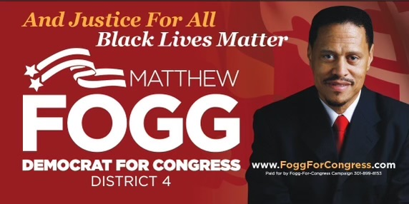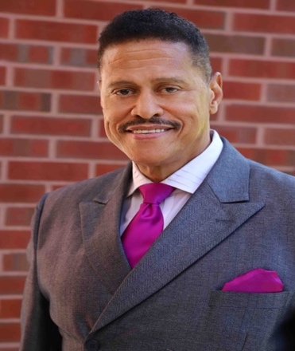
“I only regret that I have but one life to give defending the human and civil rights of others…..”

Dr. Matthew Fogg, an identical twin was born and raised up in Washington, DC. He graduated from Marshall University in West Virginia with a Bachelor of Science Degree in Criminal Justice Administration and sworn in as a deputy U.S. Marshal in 1978. In 2017, he received an honorary Doctorate in Philosophy and earned Chaplaincy degree from the Global Oved Dei Seminary & University (GODSU) in Florida.

Dr. Fogg retired as a Chief Deputy US Marshal with over thirty-two years of public service in the United States Marshals Service(USMS) and was honored, as a Top Cop aka ‘Batman’ by the highest awards from the USMS director, the US Attorney for the District of Columbia and the Federal Bar for service above and beyond the call of duty and for apprehending over 300 fugitives from justice and five from the USMS Americas’ Most Wanted fugitives.

He was cross designated as a Special Agent Group Supervisor for the US Drug Enforcement Agency (DEA). He supervised joint nationwide DEA/US Marshals federal, state and municipal dragnet operations with INTERPOL (enables police in 190 member countries to network fighting international crime) assistance, that captured fugitives from justice charged in the U.S. and abroad with terrorism, murder, rape, child molestation, armed robbery, major narcotic distribution, prison escape and many other heinous crimes.

He was a team lead member of the USMS Special Operations Group (SOG/SWAT) involving the Rodney King riots in Los Angeles, Atlanta Penitentiary riot & hostage crisis, FBI Command Center (DC) following murder of his USMS SOG Commander on Ruby Ridge in Idaho, Pan Am flight terrorist/bombing trial, protection for high profile United Nations Foreign dignitaries, Federal judges and U.S Attorneys. He received specialized SOG training in various weapons, explosive ordinance disposal and Improvised explosive devices (EOD & IED), scuba dive rescue and paratrooper jump school.

Dr. Fogg is known as the Federal law enforcement whistleblower who won a landmark ($4-million) Title VII civil rights verdict against US-DOJ. Today he is the Equal Employment Opportunity Commission (EEOC) designated Class Agent representing hundreds of black deputy US Marshals nationwide. (Matthew F. Fogg, et.al, v. Jeff Sessions, Attorney General, Department of Justice). Formerly trained as a AFGE Union Official and USMS collateral duty EEO Counselor/Investigator, he has represented (non-attorney EEO/Diversity consultant) and won many other claims for federal workers challenging administrative procedures for employment discrimination at the EEO Commission.

He received the NAACP prestigious Barrier Breakers award “blazing a path for others to follow”. He is a recognized hero and “First Responder” at Ground Zero in New York City on 9/11 rescuing one and recovering the body of a fallen New York Fire Fighter. He is the National 2nd Vice President for Blacks In Government (www.BIGNET.org), the first male National President for the Federally Employed Women, Legal & Education Fund, a former Board member for Amnesty International USA (www.AIUSA.org), a ‘Ambassador for Peace’ member of the Universal Federation for World Peace and he campaigned for the Maryland 4th District U.S. Congress seat, (www.FoggForCongress.com). He has been a guest law enforcement contributor for CNN, MSNBC, FOX News, and many other local & cable TV, radio & print media forums. He’s a highly sort after speaker and the author of his pending book titled; www.BigotsWithBadges.com, derived from a March 1997 front page feature story on his US Marshals employment journey to justice that is ongoing today and recently featured in the Washington Post (January 26, 2022). Just Goggle his name!

Some Internet Links Involving Matthew Fogg

http://tinyurl.com/glc2phm

http://tinyurl.com/oolwyfr - A black man killed every 28 hours by police or vigilantes

http://tinyurl.com/3cdmvoe - NYPD Cop admits they planted drugs to meet quotas

http://tinyurl.com/zlwx7v6 - Fogg gives commentary to RT TV on Autistic man and black counselor shot by Miami PD 7-21-16

http://tinyurl.com/7jgx5up - 2004 Amnesty International Race & Humiliation Report

http://tinyurl.com/jsbnm75 - Press Release Maryland Delegate Jill Scott announces LEO Whistleblower HB 1157 with Fogg & Williams

http://tinyurl.com/hb6w6hq > CNN W/Don Lemon, Fogg and former DA on racial disparities in the War On Drugs

http://tinyurl.com/kwsj53b - Peoples Magazine depicting Matthew Fogg on 9/11 WTC

http://tinyurl.com/glc2phm - RT TV Fogg discrimination in Ferguson is happening across America -

http://tinyurl.com/mvpcldw > Hundreds of Justice Department Attorneys Violated Professional Rules, Laws, or Ethical Standard & Administration Won’t Name Offending Prosecutors

http://tinyurl.com/gpbx46f > Matthew Fogg complete First Responder at 9/11 profile on GOV LooP

http://tinyurl.com/pzy4fse > CBS Story on Racism in the USMS with Maggie Cooper discussing Bill Scott, Zanowic and Fogg

http://tinyurl.com/jdeps4c > Under The Shadow of Death Black US Marshals Fear For Their Lives - Final Call News

http://tinyurl.com/zex4o5z > Bill Scott’s BIO

http://tinyurl.com/gosrttq > CBC Hearing In November 1997 Zanowic holding up Black Rat

http://tinyurl.com/z8z9npe > 1997 Washington Afro - DC Men Tell Horror Stories

http://tinyurl.com/hhn8ph8 RT TV Fogg comments on police use of Pepper Spray

