Dear Potential Appellant Counsel.

I, the Appellant/Dr. Matthew Fogg respectfully requests your assistance in this matter against America's premier law enforcement agency, the United States Department of Justice.

Attached are relevant documents for this case, where a Notice of Appeal was filed on October 6, 2025, in opposition to the DC Federal Court's Denial of Dr. Fogg’s attorneys' Preliminary Injunction and “Reconsideration" request.

Following the DC Federal Court docket summary below, a Memorandum from the appellant's current attorney, Don Quinn, Esq., outlines a strategy for the appeal. Quinn, Esq., is not licensed in the DC Circuit Court of Appeals. Quinn and Fogg have agreed that Dr. Fogg will seek new counsel for the appellant process.

According to historic research, this case is the longest-running litigation in American History. It is also a matter most likely of “First Impression” with what are (4) main topics, along with the issue of dereliction of EEOC requirements to protect the Class from inherent Conflicts of Interest by Class Counsel.

TOPICS FOR APPEAL

(1) Jurisdiction filed by Appellant in the DC Federal Court vs Retention at the EEOC

(2) “Estopple" the Agency briefed the EEOC that it agreed with Appellant that he properly notified the EEOC and filed the case on March 19, 2024, in the DC Federal Court during the Biden Administration era. Subsequently, the Agency reversed its position under the Trump Administration and asked the Federal Judge to “Stay" the same matter at the EEOC.

(3) Binding Appellant to a signed DC contract that was materially changed by Trump Executive Order, stripping out DEI/EEOC provisions that were the impetus for Appellant filing the original 1994 Class Complaint. The EEOC’s Office of Federal Operations (OFO), in its Final Settlement Decision of September 2, 2025, acknowledged that Executive Orders had eliminated major parts, necessitating a new Implementation Settlement Plan with multiple provisions removed. Important: What’s being enforced today is not the same contract (DC) that the Appellant agreed to back in January 2024.

(4) The settlement omitted a critical EEOC/FRCP-mandated Class Settlement "Fairness Hearing” before reaching the 9-2-25 EEOC/OFO Final Settlement Agreement.

Thanks for your consideration in this matter.,

Dr. Matthew Fogg
Appellant, 240-375-3580 Cell, Email USMarshal.Fogg@Gmail.com
1994 Original Named EEOC Complainant
Retired, Chief Deputy U.S. Marshal
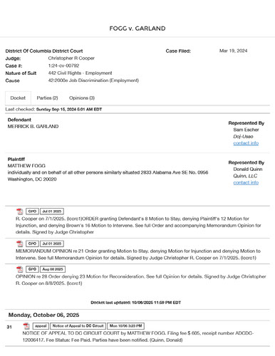

(FED/CT Case Summary) Filed March 19, 2024, Fogg V. Garland, and today, Fogg v. Bondi in the DC U.S. District Court.
Current Case Lawyer Don Quinn, ESQ Memo on Status of Case for Appeal Counsel Consideration

Current DC Court Case Lawyer Don Quinn, ESQ Memorandum (below) on Status of Case for potential Appellant Counsel Consideration

(ABOVE) MEMORANDUM OF POINTS AND AUTHORITIES IN SUPPORT OF
PLAINTIFF’S EMERGENCY MOTION FOR PRELIMINARY INJUNCTION. May 28, 2025

(Above) EMERGENCY MOTION FOR PRELIMINARY INJUNCTION TO STAY
EEOC PROCEEDINGS May 28, 2025

(ABOVE) DEFENDANT’S OPPOSITION TO PLAINTIFF’S EMERGENCY MOTION FOR PRELIMINARY INJUNCTION JUNE 4, 2025
(ABOVE) PLAINTIFFS' REPLY TO DEFENDANTS' OPPOSITION TO RECONSIDERATION OF PRELIMINARY INJUNCTION.

Federal Court July 1, 2025 Decision On Fogg’s Motion For Injunctive Relief

July 1, 2025 Court Order

DEFENDANTS' EXHIBIT - EEOC CLASS AGENTS’ MOTION TO REMOVE MATTHEW FOGG AS CLASS AGENT JUNE 4, 2025

PLAINTIFF’S MOTION TO INCLUDE EXHIBITS OUT OF TIME JULY 25, 2025

-------------------------------------------------------------------------------------------------------------------------------------------------
https://www.keepandshare.com/doc17/28840/4-24-24-usms-agency-supports-fogg-fed-ct-class-filing-pdf?da=y

Agency (DOJ/US Marshals Service Brief Agreeing With Jurisdiction Change From EEOC When Appellant Filed Class Complaint DC U.S. District Court

EMPLOYMENT OPPORTUNITY COMMISSION -
Appeal No. 2024003880 Hearing No. 570-2016-00501X
Agency No. M-94-6376 EEOC APPELLANTS DR. MATTHEW FOGG

MOTION FOR RECONSIDERATION OF EEOC DECISION DATED 9/2/25

U.S. EQUAL

