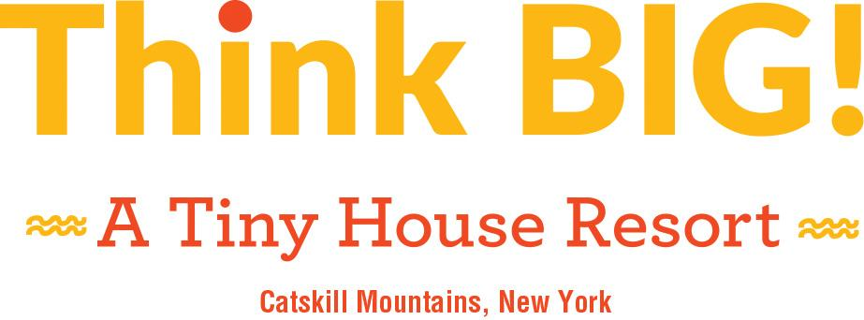
2776 County Route 23B South Cairo, NY 12482

For media inquiries, interviews and photos contact: Kim Knox Beckius, Publicist
kim@atinyhouseresort.com, 860-352-2956 (office) | 860-916-1502 (mobile)

FOR IMMEDIATE RELEASE

Think Big! A Tiny House Resort
Heads into its Second Summer Season
with New Activities and Enhanced Amenities

SOUTH CAIRO, NY, April 24, 2019—In the eastern Catskills just two hours north of New York City, the first resort of its kind in the Northeast heads into its second summer season with new enticements for guests including spa services, arts programming and goat yoga. Think Big! A Tiny House Resort (atinyhouseresort.com) has quickly earned a devoted and enthusiastic following since its September 2017 debut. This collection of nine individual and enchanting tiny houses on 28 woodsy acres overlooking the Catskill Creek offers families, couples and friends a fun-filled and luxuriously private home base in the heart of a region known for outdoor recreation, scenic splendor and the fine and performing arts.

Starting May 1, guests who inhabit these stylish tiny houses—all good-dog-friendly and equipped with kitchens, full bathrooms, WiFi, barbecue grills, patio furniture and fire pits—will have access to new activities and enhanced amenities including:

- A Wellness Tent, featuring soothing massage services for individuals and couples and a private cedar soaking tub;
- An Arts and Crafts Studio in an Airstream travel trailer, where kids and adults can work with an instructor to create one-of-a-kind vacation souvenirs;
- An inground pool, heated to 92 degrees and open for its first full summer, with robes provided for guests.

Later this summer, Think Big! A Tiny House Resort will introduce on-site yoga instruction including goat yoga classes with the property's own herd of playful goats, golf cart rentals and a guest loyalty program. These offerings join a long list of amenities already available to guests including:

- Complimentary kayaks;
- A floating river raft for relaxation;
- Daily goat walks and visits with the ducks at Waddle Inn;
- A dog park;
- Hikes to the property's waterfall;
- Gardens and a hen house, where guests can freely gather cooking ingredients.

In addition to the resort’s on-site adventures and pleasures, Greene County in the Catskills is home to hiking trails, mountain climbs, fishing streams and nine golf courses. This is the birthplace of the Hudson River School of Art, and the Thomas Cole National Historic Site and Frederic Church's Olana are both minutes away. Also nearby are HITS-on-the-Hudson horse shows, festivals and scenic skyrides at Hunter Mountain, mountain biking and Music on the Mountain at Windham Mountain Resort, and events at the LUMBERYARD Center for Film and Performing Arts.

"We're a short drive from New York City, New Jersey or Connecticut, but our guests are just amazed by the beauty and vibrance they find here," says Marjorie Juszczak, who, with her daughter Melissa, manages the resort owned by her father, Bob Malkin. Still a visionary who thinks in terms of "scale," Malkin's original, SoHo-based Think Big! gallery of oversized pop art splashed on the scene in 1979. He has ambitious plans both to expand this property and to partner for development of additional tiny house destinations.
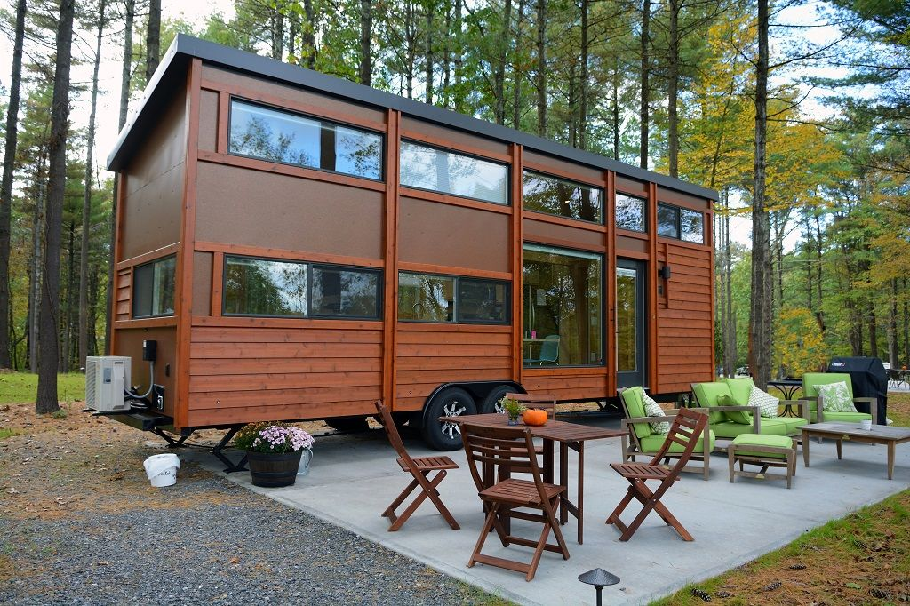
About Think Big! A Tiny House Resort

Embracing the tiny house craze, Think Big! A Tiny House Resort is a getaway destination for those who want to rediscover the natural world, personal priorities and their bonds with loved ones. With names like The Mizu, The Lodge and The Green Bean, each of the nine distinctive and adorable resort rentals has character, charm and all of the comforts of home including a kitchen, full bathroom with flush toilet and continuous hot running water, heat/air conditioning, sleep space for two to six people, WiFi, TV and a private patio with a barbecue grill and fire pit. On-site amenities include an inground heated pool, hiking trails and a waterfall, goat and duck enclosures, gardens for picking complimentary herbs and vegetables and a hen house for collecting free eggs. The Tiny Store is stocked with necessities, frivolities and free-to-borrow DVDs. Guests can book spa services in the Wellness Tent, make take-home souvenirs in the Airstream turned Arts and Crafts Studio, take private or group yoga and goat yoga classes, paddle complimentary kayaks, lounge on the resting raft, rent a golf cart and explore all the surrounding Catskill Mountains region has to offer.

For additional information about Think Big! A Tiny House Resort, visit atinyhouseresort.com or call 518-622-2626.

Follow Think Big! A Tiny House Resort on Facebook (facebook.com/atinyhouseresort/) and Instagram @thinkbig_atinyhouseresort.

# # #

