
2400 Old Milton Parkway, Box 1014 Alpharetta, GA 30009
Webpage: popeinspections.com / Webpage: www.woodflooringinspection.com
Office: 770-664-1960 ● Mobile: 404-441-4013

American Society of Home Inspectors (ASHI) Membership Number 2117
National Wood Flooring Association (NWFA) Professional License CP1520204

Home Inspection
A Limited Building Analysis Letter

Commissioning Party/ Reference: Andrew and Stacy Fotos
2295 Saxony Trace
Alpharetta, GA 30005

Date and time of this analysis: December 31, 2109 at 8:54 a.m. to 12:20 p.m.

Weather Conditions: Sunny/44°F and windy

Water pipes/drain pipes (primary): Copper/PVC

Water heater: 50-gallon gas-fired

HVAC: Gas fired Category 1 units

Electrical amperage/wire type): Est. 400, (2)200 amperes/subpanel/Copper wiring

Roof cover (shingles): Asphalt architectural grade shingles with an estimated 12 years of useful life remaining. Raised seam metal panels on the front elevation are in good condition.

Siding: Brick, cement board and stone

Porch/deck: Front (open)/Elevated rear decks

Visible framing: Conventional wood framing, I-Joists, no steel framing is visible

Date of construction: Date given 2014

Orientation: The orientation is from the perspective of facing the front door from the left side elevation.

Photos: Limited number

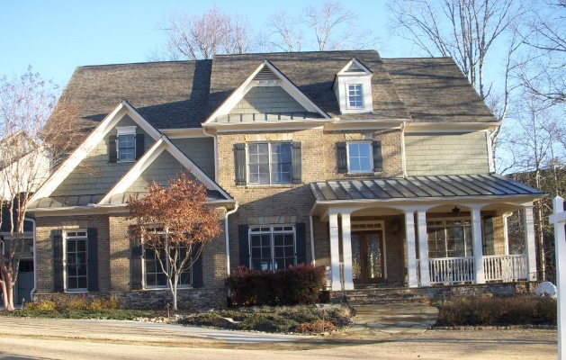
This Limited Building Analysis (LBA) letter is to certify that I have personally performed a physical inspection and analysis of the property located at the referenced address on the stared date. In attendance at the time of this inspection were the selling agent and homebuyers, plus in-and out traffic.
The subject home is a conventional single-family dwelling on a basement foundation. The LBA was made by direct visual assessment, as no invasive exploration or destructive testing was done. The contents of this report does not establish property value.

Please note, this letter is based on a limited visual and photographic survey of the accessible elements of the building. It is possible that, as repair work is performed, some features or details may be exposed that are not consistent with the information upon which this letter is based. Should this occur I specifically reserve the right to consider such information, and to supplement my findings appropriate to the new discovery.

Some items may violate ICC/IRC State Mandated Building Codes. I will state with certainty that the information contained herein does not certify that the building and its mechanical systems are in full compliance with Georgia’s Mandated Building Codes (IRC/ICC). It is the intent of this letter to capture major points as they relate to the structure and mechanical with a concentration on important issues, and as such does not contain all of the events as they pertain to the complete home presented for this inspection. This house is unoccupied and has been for an undetermined time. My liability to the Commissioning Party is limited to the consultation fee only (see GA Court of Appeals ruling).

This LBA is not intended to address any single part, section or component of the building but rather multiple parts of the structure and its mechanical systems. I may suggest or recommend action but I am not liable or accountable for any recommended repair or replacement. Consult experts in each field of repair. For the record, the inspection is a snapshot of time on the day of this inspection only.

During the inspection and discovery process a number of conditions worthy of note were observed and recorded. However, a number of items primarily related to small items of expenditure are not individually identified in this report. These item go unchallenged but may be of significant importance when conducting subsequent business with the seller.

Upon entering the home I found it clean and marked by extreme care in treatment of details. However, I did observe a number of items worthy of note.

Findings
- The rain gutter has excessive left slope at the far left front corner. This section of trough needs detaching from the fascia, raising to close the gap between the gutter and roofing shingle, then reattached to the house.
- All down spouts need work to ensure proper attachment to the in-ground drain pipes.
- All in-ground plastic drain pipes need professional cleaning and repair to ensure good flow of storm water.
- Roof water leaked between house and end of the short gutter over the small garage. There is no visible evidence of diversion flashing to turn water away from the building envelope. The condition has resulted in significant wood rot in the fascial and cornice.
- The upper left gutter is not sealed correctly at the roof line, right end of gutter, to collect storm water. The condition has resulted in substantial wood rot in the cornice.
- All seam joints in gutter troughs need sealing to prevent leakage and wood rot to the cornice assembly.

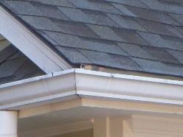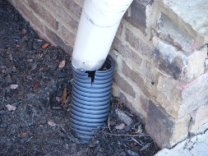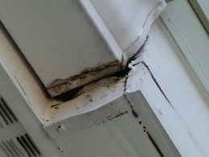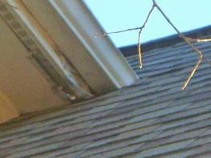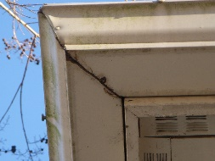

- Rusty gas pipe at the outside supply is required to be protected against corrosion; buff and paint.
- Three air condensing units located at the right side elevation were not tested by inspector as outside ambient air temperature is unfavorable. I strongly recommend acquiring a 1-year appliance warranty to ensure start up in the spring.
- Condenser/breaker compatibility and correct sizing was not confirmed. The panel index did not account for or ID the AC units. Unit 1(20 ampere); 2(40 ampere); 3(35 ampere). Before closing, match the panel breaker with the breaker size (Maximum/Minimum) listed on the specification plate on each of these condensing units.
- Lineset insulation is damaged and part is missing; repair as necessary.
- All drain pipes need to terminate not greater than 6” above the dirt line and extended outward not less than 5’ to move the discharge away from the foundation.

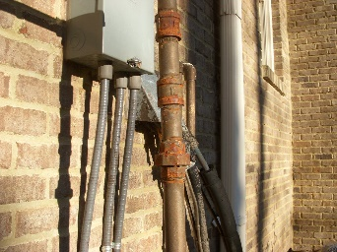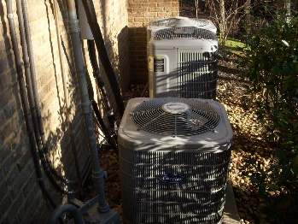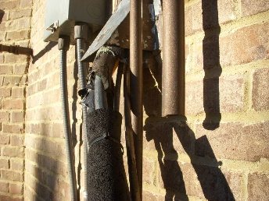

- Deck posts (wood and steel) are in contact with dirt. Remove posts from dirt and pour an appropriately sized (to code) concrete footing, leaving the top of the footing not less than 2” above the grade line.
- The lower deck landing should have a post and footing installed and not rely on physical attachment to the house with metal fasteners.
- The upper deck flashing detail is questionable and shows deterioration. It performs its intended function, but monitor this location for penetration of storm water in the future.
- The outside rim joist on the long span of the deck is spliced between support posts. This means that the deck is not fully supported vertically with a double member. In essence, this deck may not be capable of sustaining a 40/lb. per sq. ft. live load. You are encouraged to correct this condition before closing and before using this deck for family/friend gatherings.
- The upper inside end of the high deck step stringer appears unsafe and should have a post and footing support installed to carry the live and dead loads. These steps may break loose from the deck and collapse if not repaired. Unsafe!
- A horizontal brace is needed to provide addition support at the bottom end of the high deck step stringers where they meet the mid-landing.
- High deck steps stringers, lower section, are in contact with dirt. These stringers need raising above the dirt line and placed on a poured concrete pad.

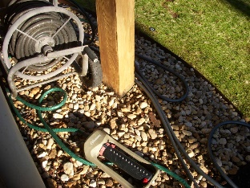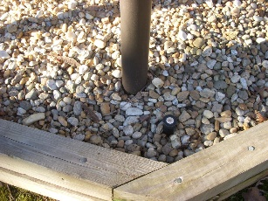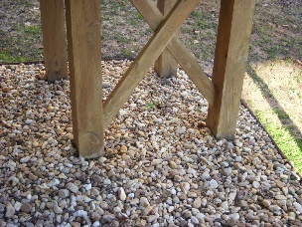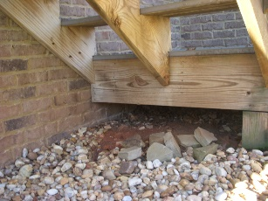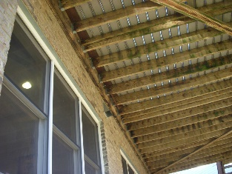

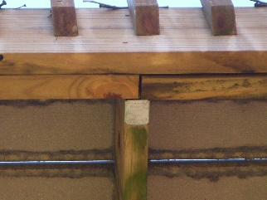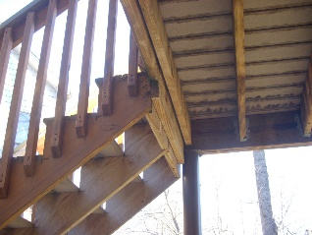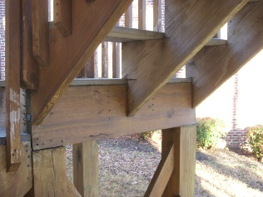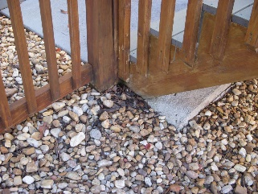

- The PVC drain pipe against the water heater vent pipe connector requires not led than a 1” clearance.
- All paper facing on insulation and other combustible paper products need removing from the mechanical room; unsafe confection…fire hazard.
- The mechanical room ceiling is not firestopped or draft stopped. Seal these openings with code approved firestopping material before closing.

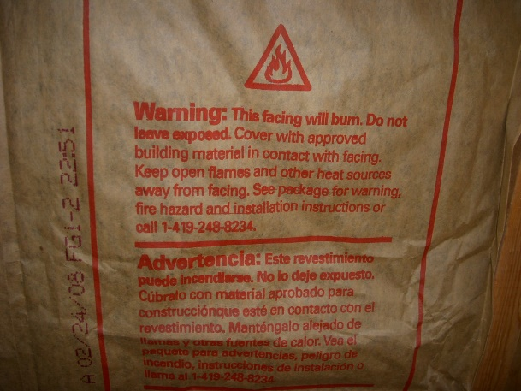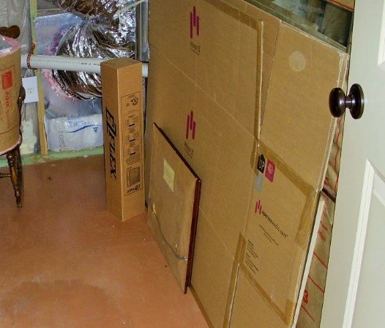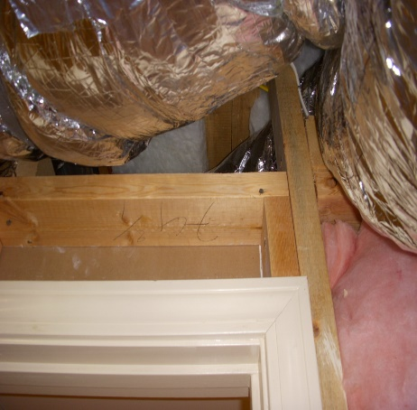

- Repeat, electrical breakers to circuit wires need correct labeling.

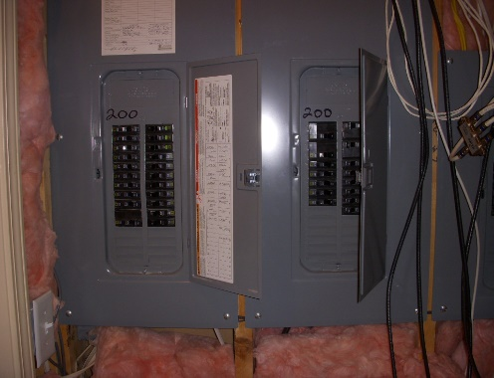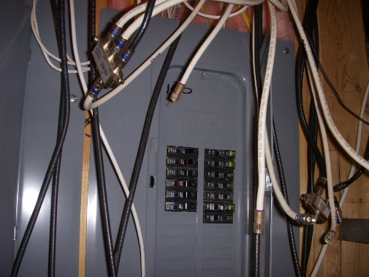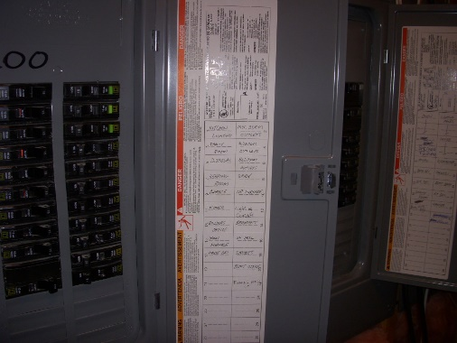

- Basement bedroom, green, does not have an openable 5.0 sq. ft. net clear egress window for fire rescue. The present openable window has a 3.7 sq. ft. net clear egress opening.
- All windows used for light and ventilation in habitable rooms must be free of easy opening. Free all windows that are stuck shut or painted shut, and also those windows that do not fully open.
- Outside electrical receptacle 14’ above the outside grade line was not tested. It would be good is the seller engages an electrician to check this outlet for functionality before closing. GFCI receptacles are prone to fail (not trip) even when new. Monitor all GFCI regularly using a proper testing device. Replace all units that do not pass the trip test.
- Door to upper deck deadbolt needs adjusting for easy operation.
- Closed door strike plate is missing, upper bedroom.

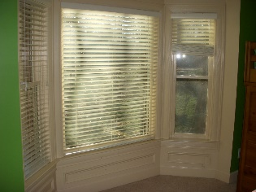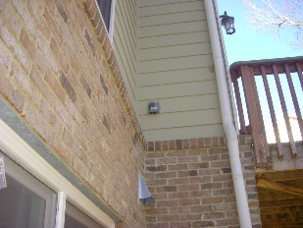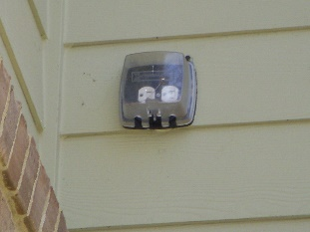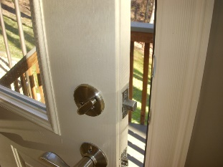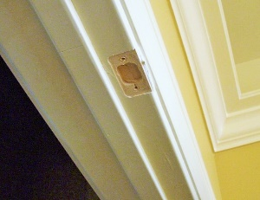

- Wood rot is highly visible at the right side looking out of the office window.
- Office window screen has three holes.
- Office window transom has a pushed out seal that cannot be repaired. Replacement of the window is strongly recommended before the condition grows worse.
- One window screen in the dining room is not set in place, and one window is missing at the front porch.
- Adjust the loose knob on door to the upper deck/great room.

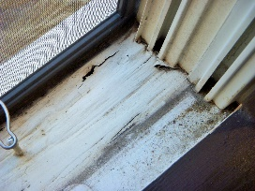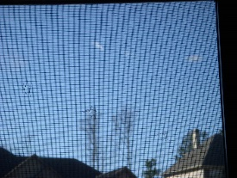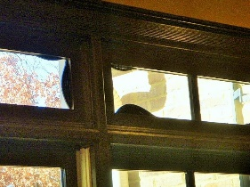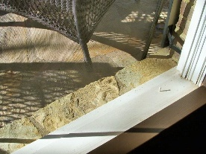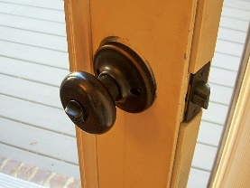

- The upper deck top cap is loose at an intermediate rail post. The screw on the right cap in not screwed into the 2x4 top rail.
- Window ledge has significant wood rot at the base of the 4-part window assembly above the high deck. The rot is noticeable especially in the ledge at window base 1-2, and wright of window base 4.
- House paint is beginning to peel of the woodwork at window ledges. Care must be taken to protect the wood from the elements and eventual rot.
- Upper right front bedroom window has a damaged sash where the window lock is broken loose.

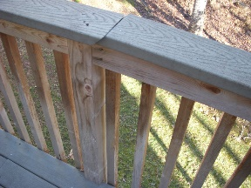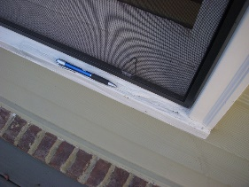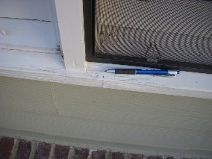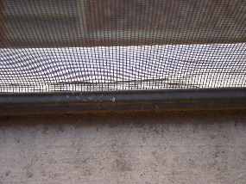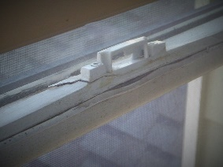

- There is not a utility catch pan under the clothes washer, and a discharge pipe is not installed to connect a pan. A pan and pipe is strongly recommended to prevent water damage to the house should washer overflow and leakage occur.
- There is no evidence of a gas connection in the event a gas clothes dryer is preferred. However, a gas supply pipe can be installed through the ceiling in the laundry room.
- Jetted tub motor access openings are required to be large enough to access the tub motor for service and repair. The motor under the master bathtub does not meet this requirement.
- There is no reasonable explanation for “cord lights” to be lying on the attic floor next to a furnace vent pipe.
- It appears the furnaces were lase serviced on 5-18-19. However, I recommend cleaning and servicing the furnaces before closing, and cleaning professionally all air ducts.
- The thermostat wire lying in the passageway to the attic furnace is a trip hazard. This set of wires need routing of the passageway and work space at the furnace. To leave these wires in place could result in the wires being ripped from the furnace.
- A protective railing should be installed across the furnace end of the walk board and along the right side of the access opening; though not a code requirement.

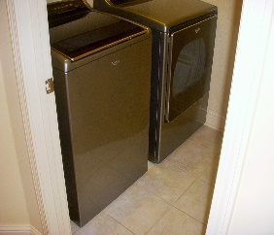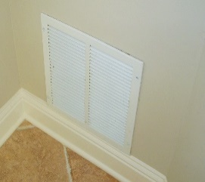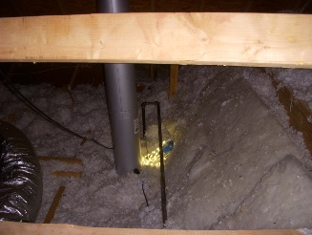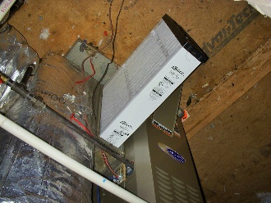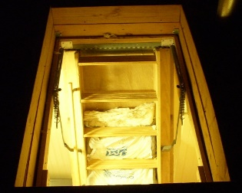

- Install new battery-operated smoke alarms and carbon monoxide detectors before closing is strongly recommended.
All repair related to trip hazards and unsafe conditions should take priority.
Worthy of Note My inspection is visual and does not employ any destructive or intrusive techniques to expose “covered” areas of view. This report is an overview relevant to the overall condition of the property. It does not rank the order in which items need addressing. All deficiencies described in this report need to be personally discussed with your expert or engineer representative, examined, judged for quality, and given the attention that the item(s) deserve before final settlement.

From the Note Pad
HVAC regular maintenance visits should be performed not less than 2 times per year. I strongly recommend an inspection and servicing of the HVAC systems by a licensed contractor, which shall include but not be limited to the following:

Cooling & Heating Systems
  - Check refrigerant charge.
  - Change air filters.
  - Check belts and change if worn or damaged.
  - Check for unusual noises and vibrations, etc.
  - Check all electrical connections for tightness and repair as needed.
  - Check operation of reversing valves (if applicable).
  - Check all fans for cleanliness and proper operation; repair or replace as needed.
  - Lubricate all moving parts.
  - Locate and repair damage and leaks within the refrigerant containment system; i.e. lineset, evaporator and condensing coils.
  - Check all vent pipe and vent pipe connectors for leakage, improper installation, improper type, unsafe conditions. Replace immediately as needed.

I strongly encourage you to complete the above list of recommended services before closing on this property, regardless of the age of the HVAC system(s).

Important Advisory It is not the intent of this letter to provide legal advice upon which you or anyone else should rely in making decisions regarding purchase or a legal claim. Laws and rules relating purchase of property are not within the scope and purpose of my work. Laws and rules governing a claim vary widely from state to state. You should always contact an attorney to obtain information as to the rules and laws pertaining to any purchase or claim you might have. For security, after writing the report my field notes are then shredded.

This Report is the full and final report. Upon successful electronic delivery of the report, I have satisfied my contractual obligation.

Beyond the contents of this report, I do not adjudicate problems in the structure without first receiving payment, which includes payment for re-inspections, expert opinions, research, case preparation, and court appearances.

Any and all liability for this consultant/inspector, Pope Inspections, Inc., Jeff Pope, Wood Flooring Inspections and Consultations shall be limited to the actual cost of the Limited Building Analysis, and nothing more. Travel and report writing time are not refundable. Any dispute regarding this letter/report must be initiated by contacting the writer (consultant/inspector) of this document. If the dispute cannot be resolved between the principal parties, the matter must then be adjudicated by a civil court of competent jurisprudence in the county in which the writer lives and the business is licensed.

I appreciate the opportunity to have assisted you with this investigation. Should you have any questions or if I can provide further help through information or action, contact this office during normal business hours.
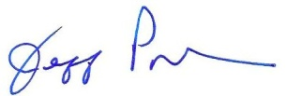
Jeff Pope

