The following three letters have been created in Microsoft Word so they can be easily copied and pasted into an email. They are designed to help the county or regional office PTA president contact schools in their jurisdiction to introduce the value of the Americans All 2.0 program and encourage their participation.
To ensure the president can send them out at any time, the initial outreach letter, Letter A, has two versions: one for the summer/pre-school year, which can be used in late spring, summer, and back-to-school planning. The other is the school-year version, which should be used from September through April.
The two versions are identical except for the first two paragraphs following the graphic. Those sections are clearly marked below. The two follow-up letters, Letters B and C, may be used at any time during the year.
Each letter starts on its own page.
This is Letter A – Initial Outreach Email to local PTA presidents
Subject line for the email: Exploring a New Funding Opportunity for Your PTA
Dear PTA President,
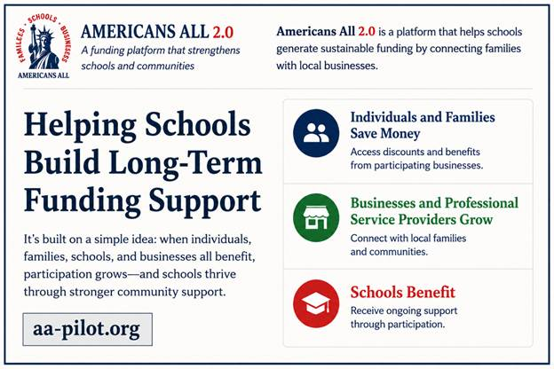
These two paragraphs are used to introduce the program in late spring,
summer, and back-to-school planning.
My name is [insert name], and I hope you have had a successful school year. As schools and PTAs begin planning for the fall, I wanted to introduce Americans All 2.0, a community-based funding platform developed to help schools generate long-term support through voluntary involvement from families, businesses, and professional service providers.
Traditionally, most PTAs rely heavily on fundraising events, product sales, donation drives, and volunteer time. While those efforts remain important, they can also be difficult to sustain year after year.

These two paragraphs are used to introduce the program during
the school year, which will be effective from September through April.
My name is [insert name], and I hope your school year is going well. I wanted to introduce Americans All 2.0, a community-based funding platform designed to help schools generate recurring community support through voluntary participation from families, businesses, and professional service providers.
The program was created to complement existing fundraising and community participation efforts while helping schools build stronger long-term relationships within their communities.
The following text is the same for both versions.
Americans All 2.0 was created as a different approach — a low-burden supplemental funding platform designed to support existing fundraising efforts without creating additional work for volunteers.
To help minimize administrative burden, we have also prepared optional communication outreach resources that participating PTAs may use with families, businesses, and professional service providers. There are:
- No products to purchase
- No inventory to manage
- No delivery logistics
- No event setup required
Instead, the platform encourages voluntary involvement from the school community and connects families with local businesses and professional service providers that want to reach and support that audience. Businesses and professional service providers offer discounts, promotions, and other benefits to members and can update their offers daily. Our platform is built to:
- Help schools generate recurring financial support through participation.
- Help individuals and families access discounts, benefits, and promotions.
- Help businesses and professional service providers strengthen community relationships through flexible promotions and benefits while improving the effectiveness of their local marketing efforts.
We are currently conducting a pilot program designed to evaluate community interest, gather feedback, and refine the model before broader expansion. We are seeking a limited number of PTAs willing to:
- Learn more about the concept and provide feedback.
- Help us evaluate how communities respond.
- Explore whether the program may help PTAs increase membership.
- Help refine the model before broader expansion.
If you are open to a short introductory conversation, I would be happy to provide additional details about the program structure, including how participating businesses financially support schools and PTA organizations, and to answer any questions you may have.
Thank you for everything you do to support your school and its community.
Best regards,
[The following is a sample signature block and can be modified as needed.]
Regional PTA President’s name
Title: President, [County/Regional PTA Name]
Email
Phone number
aa-pilot.org

This is Letter B – First Follow-Up Email to Local PTA presidents
Subject line for the email: Following Up - Americans All 2.0 Community Pilot
Hello [PTA President Name],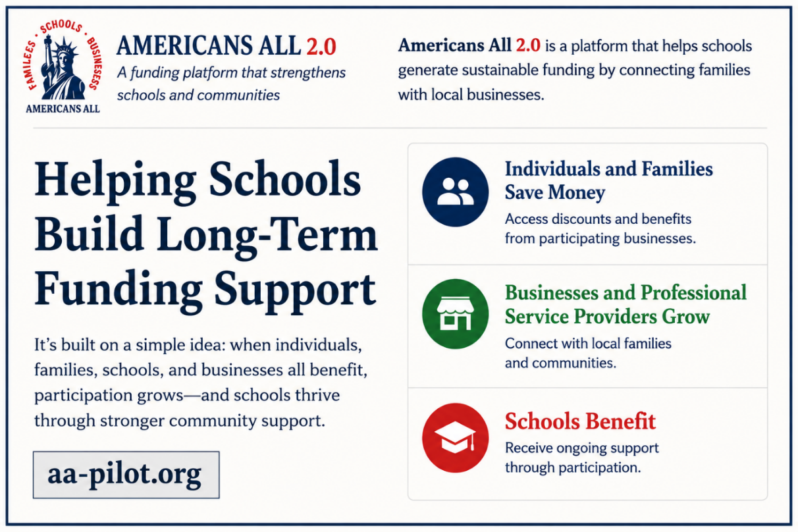
I wanted to briefly follow up regarding my earlier email about Americans All 2.0.
We understand that PTA leaders already have a great deal on their plates, which is exactly why we
designed this model to work alongside existing efforts without creating additional work for volunteers.
Our goal is to explore whether schools and families would support a long-term funding model built around everyday involvement rather than repeated fundraising campaigns.
The pilot phase is especially important to us because we want meaningful feedback from PTA
leaders before expanding further.
We have also prepared optional communication materials and outreach resources that
participating PTAs may use with families, businesses, and professional service providers.
If you would be open to a short call, I can walk you through the concept, explaining how
participating businesses financially support schools and PTA organizations, and get your thoughts.
Thank you again for your time and leadership.
Best regards,
[The following is a sample signature block and can be modified as needed.]
Regional PTA President’s name
Title: President, [County/Regional PTA Name]
Email
Phone number
aa-pilot.org

This is Letter C – Final Follow-Up Email to Local PTA presidents
Subject line for the email: One Final Follow-Up—Americans All 2.0
Hello [PTA President Name],
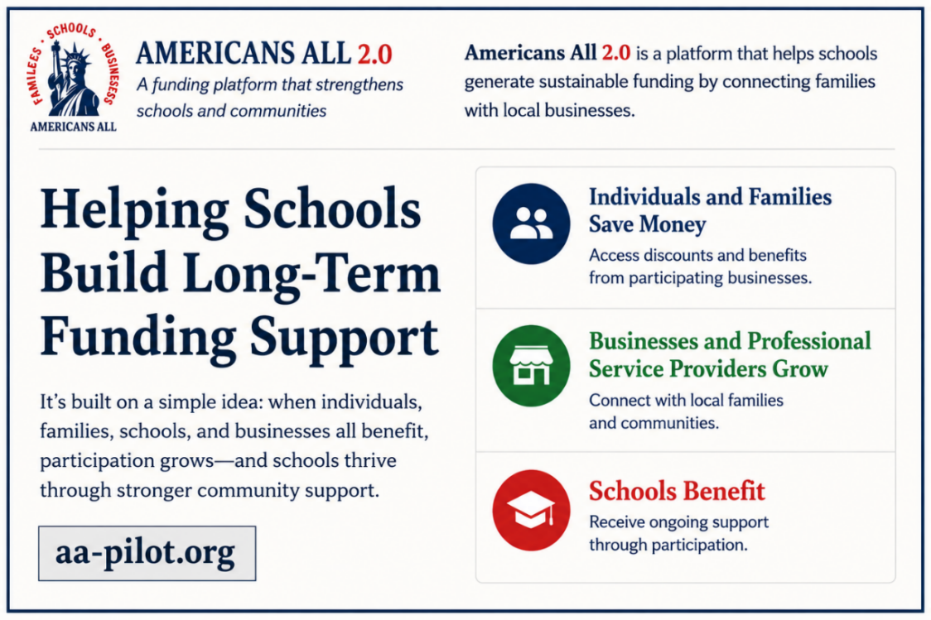
I know schedules can get busy, so I wanted to send one final follow-up regarding Americans All 2.0.
We believe schools may benefit from additional funding approaches that are:
- Sustainable over time
- Easier to manage
- Community-driven
- Less dependent on repeated fundraising events and ongoing volunteer demands
Americans All 2.0 is being developed as a supplemental funding platform designed to support schools and PTA organizations through ongoing community involvement.
Our pilot discussions are helping us evaluate whether this model can become a meaningful long-term resource for schools, families, and communities.
We have also prepared optional communication materials and outreach resources that participating PTAs may use with families, businesses, and professional service providers.
Even if now is not the right time, I would still value any feedback or thoughts you may have regarding the concept.
Thank you again for the work you do for students, families, and your community.
Best regards,
[The following is a sample signature block and can be modified as needed.]
Regional PTA President’s name
Title: President, [County/Regional PTA Name]
Email
Phone number
aa-pilot.org

